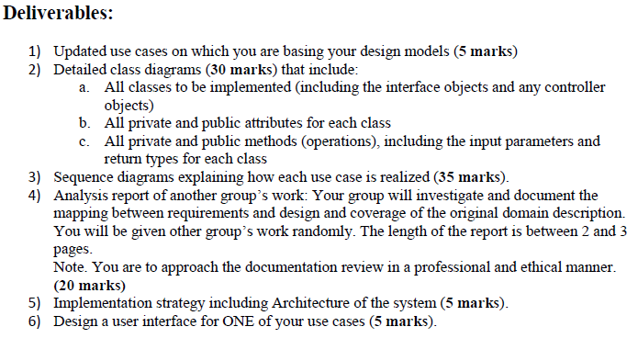

**Deliverables:**

1) Updated use cases on which you are basing your design models (5 marks) 2) Detailed class diagrams (30 marks) that include:

a. All classes to be implemented (including the interface objects and any controller

objects) b. All private and public attributes for each class c. All private and public methods (operations), including the input parameters and

return types for each class 3) Sequence diagrams explaining how each use case is realized (35 marks). 4) Analysis report of another group's work: Your group will investigate and document the

mapping between requirements and design and coverage of the original domain description. You will be given other group's work randomly. The length of the report is between 2 and 3 pages. Note. You are to approach the documentation review in a professional and ethical manner.

(20 marks) 5) Implementation strategy including Architecture of the system (5 marks). 6) Design a user interface for ONE of your use cases (5 marks).